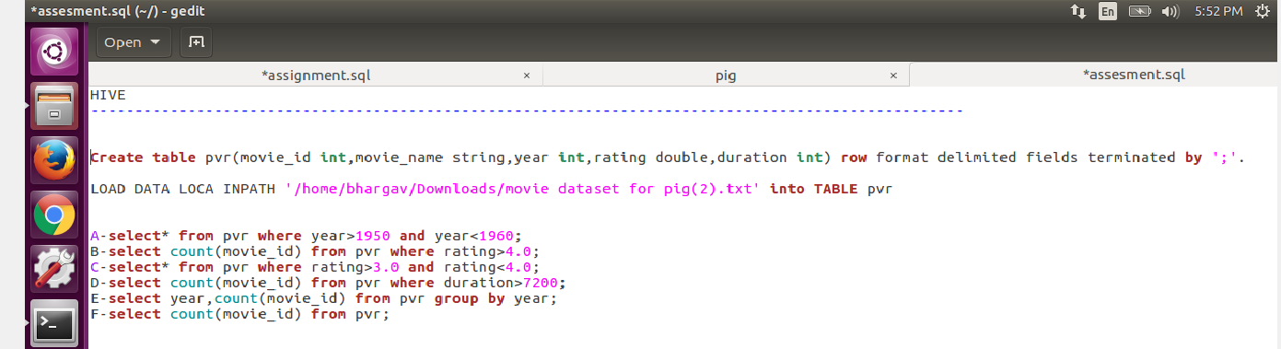

HIVE:---------------------------------------------------------------------

Create table pvr(movie_id int ,movie_name string,year int,rating float,duration double) row format delimited fields terminated by ';'.

LOAD DATA LOCAL INPATH '/home/bhargav/Downloads/movie dataset for pig(2).txt' into TABLE pvr

A- select* from pvr where year>1950 and year<1960;

B- select count(movie_id) from pvr where rating>4.0;

C- select* from pvr where rating>3.0 and rating<4.0;

D- select count(movie_id) from pvr where duration>7200;

E- select year,count(movie_id) from pvr group by year;

F- select count(movie_id) from pvr;

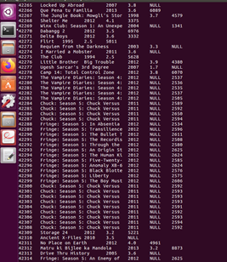

A- select* from pvr where year>1950 and year<1960;



B- select count(movie_id) from pvr where rating>4.0;

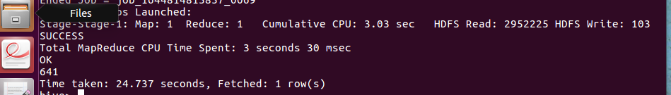

D- select count(movie_id) from pvr where duration>7200;

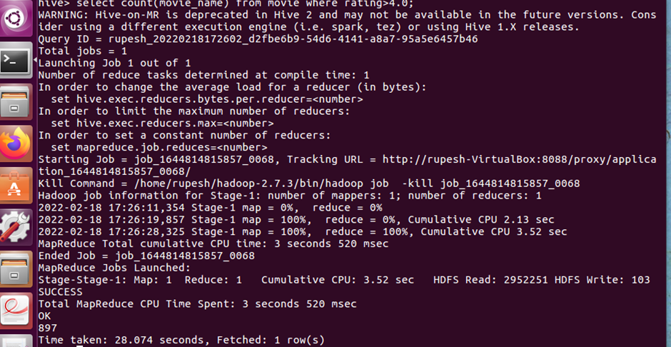

C- select* from pvr where rating>3.0 and rating<4.0;

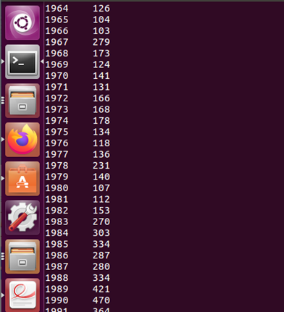

E- select year,count(movie_id) from pvr group by year;

PIG

